NATIONAL INVESTMENT TRUST LIMITED

BID EVALUATION REPORT
Tender No: |  | TS541672E
Tender Date: |  | 12/6/2024
Tender Title & Scope of Work: |  | TENDER TO AUTHORIZED PARTNERS FOR PROVIDING MAINTENANCE SUPPORT OF VIDEO CONFERENCING EQUIPMENT AT KARACHI AND ZOOM CLOUD ACCOUNT
Bidding Procedure: |  | Single Stage one Envelope Procedure
No. of Bids Received |  | 01 positive bids
Tender Opening Date : |  | 28/6/2024
Details of Bid Evaluation:
VENDORS | Technical  Qualification Status | Evaluated Cost (Rs.) | Basis for Bid Acceptance / Rejection
 | 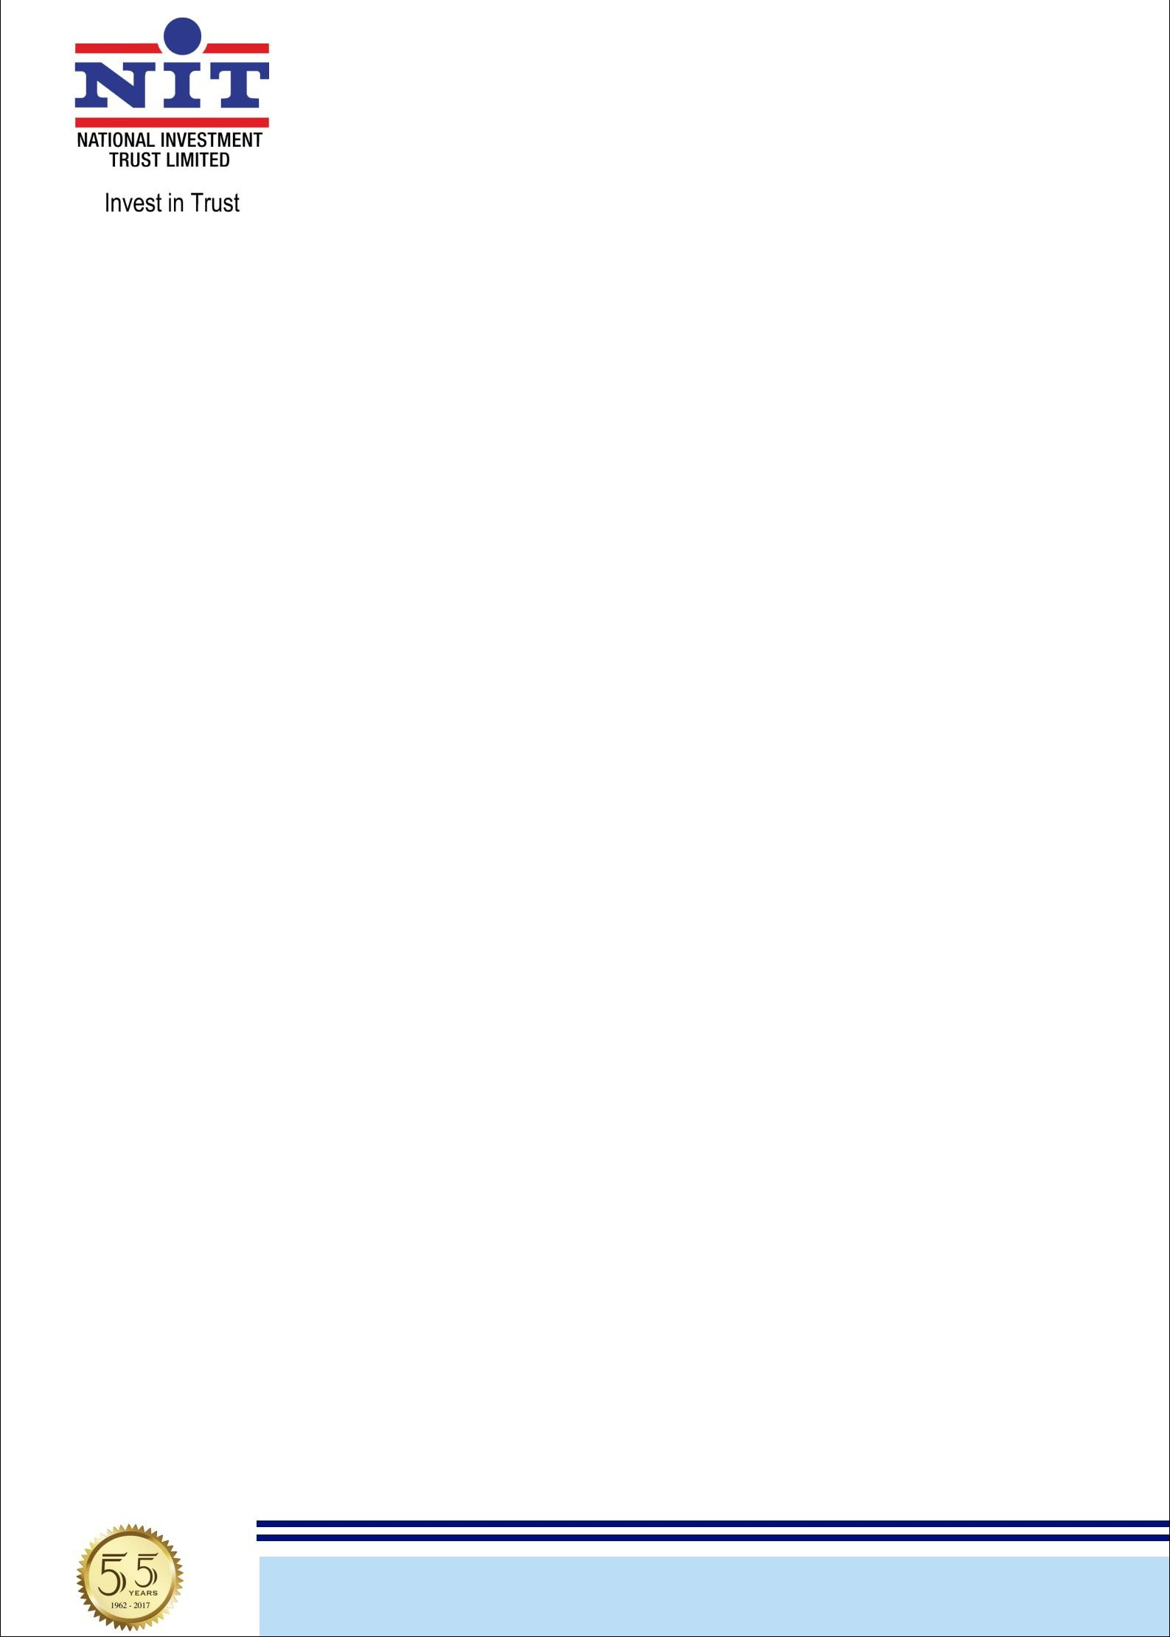
M/s. Mansha Brothers | Qualified | Rs.820,666.45 (Polycom VCS)  Rs.343,756.37 (Zoom)  Total Rs.1,164,423.00 | Conforms to bid evaluation criteria
Lowest Evaluated Bidder. M/s. Mansha Brothers

NBP Building, 6th Floor, I.I. Chundrigar Road, P.O. Box 5671, Karachi-74000, Pakistan.
UAN: 111-648-648 Tel: 32412056-9 (4 Lines) Fax: 32422719, 32417827 Email: info@nit.com.pk Website: www.nit.com.pk

