Commander MES (DP)
Railway Road Chaklala
Tele No. 9280491
No.6018-DP/ 152 /E-6

05 May 2025

To: I.S.P.R Directorate
GHQ Rawalpindi
addispr@yahoo.com

To: Mr. Rizwan Mehmood,
Assistant Director – II
Public Procurement Regulatory Authority,
1st Floor FBC Building Near State Bank,
Sector G-5/2, Islamabad

Subject REQUISITION FOR ADVERTISEMENT : NOTICE OF TENDERs

Copy of requisition is enclosed herewith for loading on PPRA website, please.

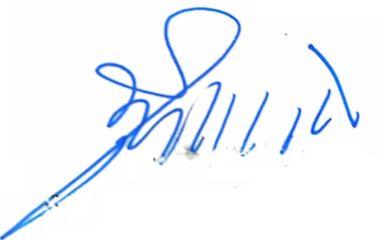

A/XEN B&R (AQS)
DA/ As above For Comd MES (DP) Ckl
(Rashid Mehmood)

Copy to: -

- GE JSHQ Ckl, GE NDU,  GE Maint (DP) Chaklala | Please ensure making of payment on receipt of  advertisement bills from respective agencies.

MILITARY ENGINEER SERVICES – NOTICE OF TENDER
FOR PRE-QUALIFICATION

Ref: CMES (DP) Ckl No. 6018-DP/ 152/E-6 dated 05 May 2025.

1. Applications pre-qualifications of Govt Auctioneers are invited by the Commander MES (Defence Production) Railway Road Chaklala Rawalpindi up to 22 May 2025. Tender documents of the work will be delivered to qualified Auctioneers / firm later on . The tender must be received by 1130 hrs and will be opened at 1200 hrs on prescribed date.

Name of works:-

 |  |  | Period
a. | Appointment of Govt Auctioneer for the auction of MES unserviceable and surplus store / items of E-in-C’s Branch, DW&CE (DP), GE JSHQ Ckl, GE NDU Isld and GE Maint (DP) Chaklala | - | For One Year

2. Govt Auctioneers who are enlisted a approved Govt Auctioneer may only apply. Firms/ Auctioneer not borne on approved list will furnish a certificate along with their application, giving details of auctions executed during last two years and those in hand.

3. Firms/ Auctioneer, not borne on approved list will furnish with their application proof of their being on the appropriate list of the Department concerned, a statement of financial standing with necessary bank certificate, details of staff employed, details of tools and plants and previous experience giving details and type of work, executed in the last two years and in hand duly attested by Class-I Gazetted Officer.

