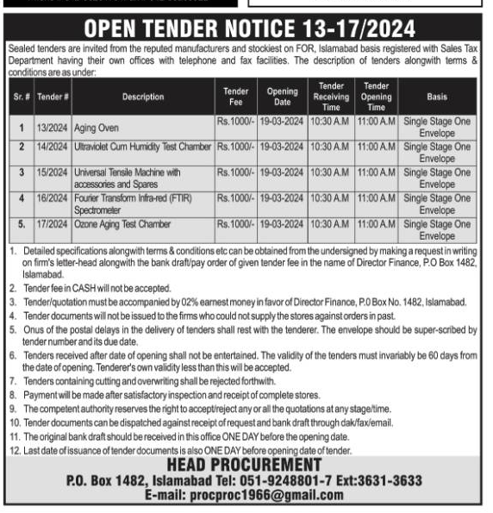

The Nation Newspaper

16-02-2024

