Central Ordnance Depot
Rawalpindi
Tel: GHQ – 34729
18/ Normal/ Corrigendum
9 April 2024

To: PPRA Islamabad

Subject: Request for Uploading of Corrigendum in Tender - 19 Normal - (TS536260E)
1. 7x additional items are required to be procured through LP. Please add the same as corrigendum in Anx A to Central Ordnance Depot Rawalpindi tender inquiry number 19/Normal/LP dated 2 April 2024, available on PPRA website vide ID: TS536260E with opening date on 17 Apr 2024.
2. Forwarded for publication at PPRA’s website immediately, please.

Lt Col
LPO
(Naqeeb ur Rahman)

Annexure A
Invitation to Tender for Procurement of (Single Stage Two Envelope procedure)
Multisource Aviation Refueling System (MARS) FY- 2023/24

Ser | Nomenclature | A/U | Rate | Remarks
MULTISOURCE AVIATION REFUELING SYSTEM (MARS)
 | Filter Housing, Parker Velcon, USA,  Model VF-61 | Nos |  | GSR and pictures att at Appendix I to Annexure A
 | Micronic Filter Cartridge  Part no ACO-512P3R Rating - 0.3/ 0.5 Micron 5PPM | Nos |  | GSR and pictures att at Appendix I to Annexure A
 | GPI, G-PRO Avn Fuel dispensing pump with flowmeter, 25 GPM, Model V25-012PX  Make - USA | Nos |  | GSR and pictures att at Appendix I to Annexure A
 | 1 Inch Dia, 70 x ft Avn AI 1529 std hose, with end NPT fittings Elaflex, Germany | Nos |  | GSR and pictures att at Appendix I to Annexure A
 | DP Gauge, SS 0-30 psi  Model GTP-534-305 Make- Gammon, USA | Nos |  | GSR and pictures att at Appendix I to Annexure A
 | Auto Shut off Avn Nozzle, 1 inch  Model ZVA-25 Make- Elaflex, Germany | Nos |  | GSR and pictures att at Appendix I to Annexure A
 | Hose Reel | Nos

Appendix I to Annexure A
GSRs - MULTISOURCE AVIATION REFUELING SYSTEM (MARS)
Ser | Nomenclature | GSR | Remarks
Suction / Intake of fuel
 | 20 ft suction hose with foot valve | Appropriate 33 Inch Stain less steel Pipe is required.
 | Coupling for Bozer | Adjustable Camlock Stainless Steel couplings for 3 inch and t inch bozer arrangements.
Dispensing Pump
 | Minimum acceptable flow rate is 70 liter per minute | GPI, USA 95 LPM capacity dispensing fuel pump, fuel pump with flameproof motor, the nozzle end flow will not be less than 70 LPM (Temperature Range - 30ºC to 52ºC)
Flow Meter
 | Digital / Analog flow meter | GPI Flow meter, Trip and Cumulative life counting.
Micronic Filtration
 | Housing certificate to API 1581 standards | Parker Velcon Filter Housing (VF-61), USA (uses 12 inch elm, same filter housing being used in AFBs deviated by MVRDE Rwp)
 | Min 0.5 micron Filter Cartridge with min 5 ppm water removal cap | 12 x 6 Inch, 0.5 Microns (Velcon USA) (ACO series Aquacon hybrid filter elm, being used in AFBs)
 | DP Gauge | Garmmon USA, DP Gauge with proper fittings
Hose
 | 50 Ft del hose | AI 1529 standard, 1 inch Elaflex (Germany)/ Hewwitt USA Av Standard fuelling hose, meeting the desired flow rate required.
Hose Reel
 | Spring Loaded/manual op Hose reel for 50ft hose | Aviation fuel standard, EU/PRC origin, Spring loaded/ manual operator reel
Nozzle
 | Automatic nozzle | 1 inch automatic nozzle to meet flow (OPW/ Huskey/ GPI)
Sys Design / Platform
 | Portable Trolley based | Light weight Trolley based portable system
Allied Gadgetries
 | Fire Extinguisher | 4 KG DCP cylinder with mounting clamps
 | Tool kit | Necessary tools provided
 | Dust proof cover | Yes
Electrical Connections
 | Min 20 ft connection cable with alligator clips | 20 ft power cable connections with imported reverse polarity protection circuit breaker.
 | Grounding connections | Continuous ground connection

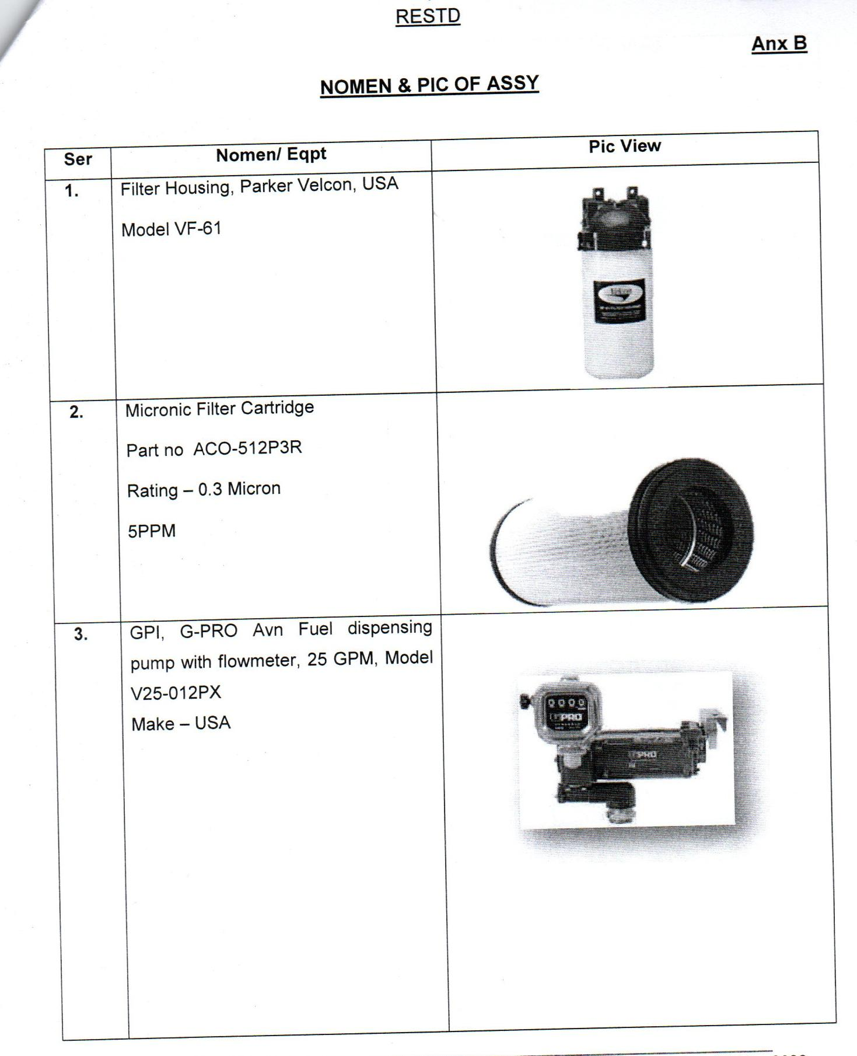

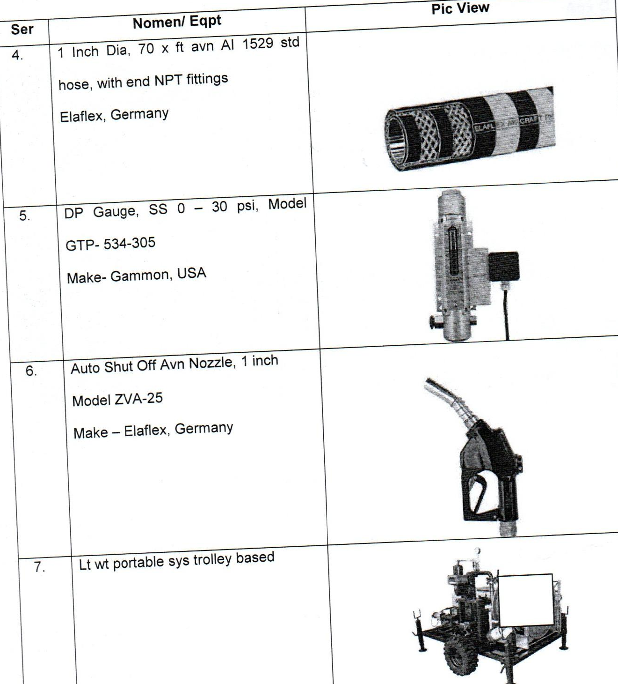

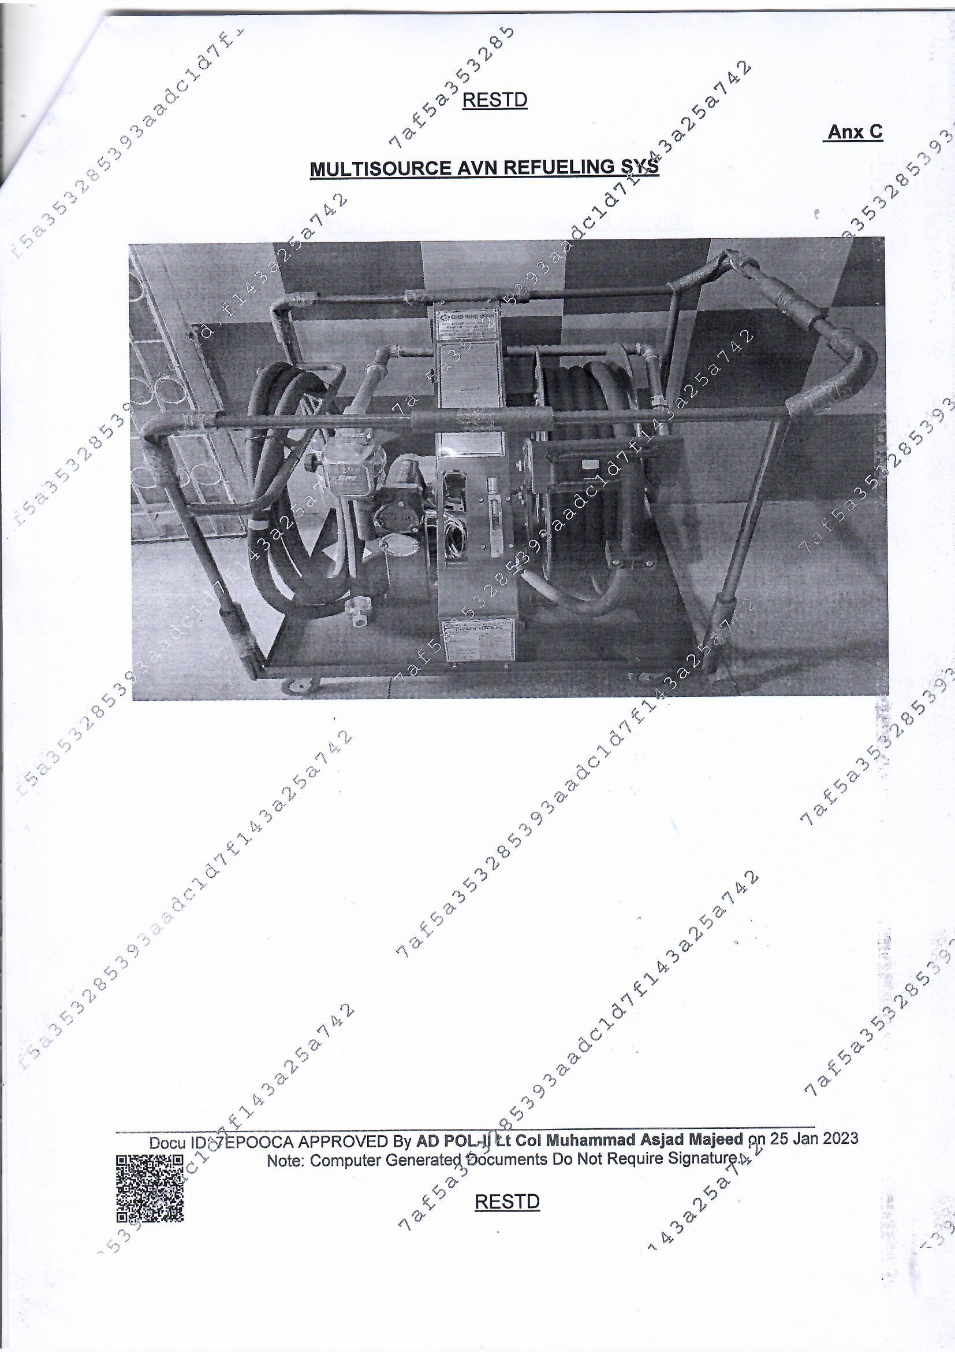

Central Ordnance Depot
Rawalpindi
Telephone : 051-8770950
0344-6019215
19 / Normal / 2023-24
01 Apr 2024

Subject: Invitation to Tender and General Instructions for Procurement of ASC Items FY- 2023/24

1. This Invitation to Tender/Bid (here in after referred to as IT), follows the Procurement on the subject, with following time lines:-
a. Date and time of closing of this IT is 17 Apr 2024 at 1030 hours.
b. Date and time of opening of bids/IT Documents offered in response to this IT is
17 Apr 2024 at 1100 hours in Conference Room of Central Ordnance Depot Rawalpindi (COD Rwp), Fort Road, Rawalpindi with representatives of bidders in attendance.
2. Sealed Bids are invited (in line with Single Stage, Two Envelop Process as specified in PPRA Regulations) from Original Equipment Manufacturers (OEMs), Agents of OEMS, authorized distributors and suppliers, which are registered with Income Tax & Sales Tax Departments, on Active Taxpayer List (ATL) of Federal Board of Revenue (FBR) and Registered with Directorate General Defense Purchase (DGDP) / Directorate General Procurement-Army (DGP-A) / Any Ordnance Depots of Pakistan Army and Pakistan Engineering Council (PEC) for supply of items as under:-
a. Schedule of Requirements is given at Annexure A.
b. Instructions for Bidders and Terms / Conditions of Bidding and Purchase are given at Annexure B.
c. Format of Vendor Profile / Qualification Documents is given at Annexure C.
d. Format of Financial Proposal is given at Annexure D.
e. Format of Technical Proposal and technical specifications of required stores/goods/equipment for relevant stores/goods/equipment are given at Annexure E.
f. Bids are to be submitted in two separate sealed envelopes, clearly marked on the outside in bold letters as “TECHNICAL PROPOSAL - IT FOR PROCUREMENT OF ASC ITEMS NUMBER 19/NORMAL/2023-24” and “FINANCIAL PROPOSAL - IT FOR PROCUREMENT OF ASC ITEMS NUMBER 19/NORMAL/2023-24” along-with name of bidding firm / entity. For ease of consolidation / identification, both the envelops may be placed in another/outer envelope clearly marked on the outside in bold letters with subject of this tender and name of bidding firm / entity.
g. Vendor Profile / Qualification Documents as per details mentioned at Annexure C, must be submitted in separate envelop (separate from both the Technical and Financial Proposals), clearly marked on the outside in bold letters as “VENDOR’S PROFILE / QUALIFICATION DOCUMENTS – IT FOR PROCUREMENT OF ASC ITEMS NUMBER 19/NORMAL/2023-24” along-with name of bidding firm/entity.
h. IT Documents along-with original hard-copies of Financial Proposal, Technical Proposal and Vendor Profile / Qualification Documents properly filled in, and enclosed in separate sealed envelope(s) as mentioned above, along-with digital-copies on separate CDs/DVDs packed in respective envelops, must be delivered to Central Ordnance Depot Rawalpindi, Fort Rd, Rawalpindi Cantonment, before 1030 hrs on 17 Apr 2024.
i. Failure to submit complete documents / details as asked OR failure to submit Technical Proposal, Financial Proposal and Vendor Profile / Qualification Documents in separate sealed envelopes is liable to cause outright rejection of bid.
j. Bid Security equal to 5% of estimated bid value is to be deposited within five working days of intimation from / asking by COD Rwp, failing which bids are liable to be rejected.
k. Procurement is planned within Current Financial Year (CFY) either in full or in part. Quantities can be amended/ decreased at the time of placing the order.
l. Along with tender, each firm will deposit Rs 3000/- as Tender Fee (in the shape of CDR, Pay Order or Cross Cheque). Same will be prepared in the name of Comdt COD Rwp.
3. All bidders are bound by Official Secret Act to ensure confidentiality of bids and purchases of Security Equipment and not share information / details of bid/contract/quantities/delivery locations with anyone not party to the bid / purchase.
4. Complete Set of IT Documents can be obtained from Local Purchase Office, COD Rawalpindi, Fort Road, Rawalpindi (Telephone : 051-8770950, 0344-6019215) on any working day between 0830 hrs and 1530 hrs.

Lieutenant Colonel
Local Purchase Officer
(Naqeeb Ur Rahman)

Annexure A
SCHEDULE OF REQUIREMENTS

PROCURMENT OF ASC ITEMS TENDER NUMBER 19 NORMAL FINANCIAL YEAR 2023/24 – COD RWP
Ser | Part No | Nomenclature | A/U | Qty | Remarks
1 | EI-7660-1027 | Heavy Duty Racks for Ghee/Oil  Ground plus 3 x shelves with 1.5 Ton Capacity per shelf (L 8.75 ft, W 3.5 ft, H 14 ft) with Oil Trays & Drain Pipes | Nos | 80 | Technical specifications are pasted below
2 | EI-7460-1165 | Racks for Gen Purpose  Ground plus 4 x shelves with 1 Ton Capacity per shelf (L 8.75 ft, W 3.5 ft, H 14 ft) | Nos | 80
3 | EI-3990-1169 | Plastic Pallets (4 ft x 4 ft) | Nos | 960
4 | EI-3930-657 | Pedestrian Pallet Stacker  Loading Capacity 700-800 Kgs, Lift Height 12 -13 ft Should be able to operate in 7 ft aisle | Nos | 02

Annexure B
INSTRUCTIONS FOR BIDDERS AND TERMS / CONDITIONS OF BIDDING AND PURCHASE
TENDER NUMBER 19 / NORMAL / 2023-24

Instructions For Bidders
1. Eligible Bidders. A Bidder submitting bid/tender in response to this IT may be a person / Sole Proprietor, a Company or Firm or Agency (Private, Limited, Public or Semi-Public) having one or more than one owners/partners and must be registered in Pakistan. Detailed requirements as under:-
a. Bidder must be Original Equipment Manufacturers (OEMs), Agents of OEMS, Authorized Distributer or Supplier and must be registered with Income Tax & Sales Tax Departments and on Active Taxpayer List (ATL) of Federal Board of Revenue (FBR). Documentary proof for all of this must be provided.
b. Must be registered with Directorate General Defense Purchase (DGDP) / Directorate General Procurement-Army (DGP-A) / DP-Navy / DP-Air / Any Ordnance Depot of Pakistan Army and Pakistan Engineering Council-PEC.
c. Must be incorporated or licensed by the respective incorporating agency or statutory body established in Pakistan for its particular trade or business.
d. Must not quote more than one rate for an item of identical brand / specs / quality.
e. Must provide complete details and documentation as specified in Vendor Profile / Qualification Data format given at Annexure D.
f. Must not be Blacklisted, bankrupt, insolvent, debarred due to involvement in corrupt and fraudulent practices, subject of any performance failure in Contracts / Agreements / Purchase-Orders from above mentioned procurement organizations.
g. Must submit bid security as specified in this IT with-in the timeline specified.
h. Must provide evidence of their eligibility, capacity, capability to perform and deliver the goods / services being contracted and must provide proof of compliance with the necessary legal and procedural requirements to carry out the contracted work effectively.
i. Must declare in IT documents details relating to the nature, conditions and modalities of sub-contracting by bidder (if planned / envisaged by the bidder), wherever such sub-contracting of any elements of the bid is amounting to the more than ten (10) percent of the bid value for such element.
j. Must provide proof of relationship with OEM or foreign principal and/or copy of Master Level/Service Agreement with such OEM or foreign principal in case of imported items.
k. Must provide valid proof in IT Documents that bidder has the financial, technical, installation and supply / production capability necessary to perform the Contract / Framework Agreement.
2. Preparation and Submission of Bid / Tender Documents
a. Complete set of forms and documents as per the given format and requirements mentioned at Annexure E shall be submitted as “Technical Proposal” in two hard-copies on bidding firm’s letter head and one digital-copy on CD/DVD duly packed in a sealed envelope clearly marked in bold letters on outside of envelope “Technical Proposal – IT For Procurement of ASC ITEMS Number 19/Normal/2023-24””along-with name of bidding firm / entity.
b. Complete set of forms and documents as per the given format and requirements mentioned at Annexure D shall be submitted as “Financial Proposal” in two hard-copies on bidding firm’s letter head and one digital-copy on CD/DVD duly packed in a sealed envelope clearly marked in bold letters on outside of envelope “Financial Proposal – IT For Procurement of ASC ITEMS 19/Normal/2023-24”” along-with name of bidding firm / entity.
c. Complete set of forms and documents as per the given format and requirements mentioned at Annexure C shall be submitted as “Vendor’s Profile / Qualification” in two hard-copies on bidding firm’s letter head and one digital-copy on CD/DVD duly packed in a sealed envelope clearly marked in bold letters on outside of envelope “Vendor’s Profile / Qualification Documents - IT For Procurement of ASC ITEMS 19/Normal/2023-24”along-with name of bidding firm / entity.

3. Contents of IT Documents and Eligibility of The Bids.
a. The bidder is expected to obtain complete IT Documents and their addenda from COD Rwp and examine all instructions, forms, terms and specification mentioned in such documents. Failure to furnish all the information required in the IT Documents will be at the Bidder’s risk and may result in the rejection of his Bid.
b. Bid / IT Documents prepared by the bidder, as well as all correspondence and documents relating to it shall be written in the English language. Supporting documents, brochures, printed-literature furnished by the Bidder, if in any another language must be accompanied by a certified accurate translation of the relevant pages in the English language.
c. The bid / IT Documents will be considered valid for consideration if it constitutes following components. Any violation of these aspect may render the submitted bid / IT Documents liable to rejection:-
(1) Financial Proposal and Price Schedule as per format given at Annexure E, duly printed on company/firm’s letter head and signed by authorized signatory. Bidder must fill the form without any alterations to its format.
(2) All items must be listed and priced separately. In case of no bid against any item, NO BID shall be printed in the price colum. If any item/accessory is not listed/ priced by the bidder, its price shall be construed to be included in the prices of other items.
(3) Unit price as well as total price of item must be inclusive of all applicable taxes, duties, levies and inclusive of cost of transportation, insurance and other related expenses for delivery of goods to their final destination.
(4) Rate of each item must be quoted exclusive of other items listed in the tender and the purchaser will have the liberty to accept bid of one or all of the items quoted and for complete or partial quantity of any item(s). The price quoted should not be contingent upon award of contract for a specific/full quantity of the item and/or award of contract for all items listed in Schedule of Requirements collectively from the same bidder.
(5) Rates / Prices quoted must be valid till 30 June 2024(for acceptance of bid / award of contract) and till completion of complete delivery of all contracted items (after the framework agreement / Purchase-Order is awarded).
(6) Prices / rates must be quoted in Pak Rupees, for delivery of goods/equipment DDP Incoterms at Rawalpindi and must be inclusive of all applicable taxes, duties and FE conversion rates where applicable.
(7) Bidder must accept to receive Purchase Orders against the framework agreement concluded after acceptance of his bid, from multiple Ordnance Depots / Central Ordnance Depot across Pakistan. Payment against goods / equipment delivered in response to the above mentioned Purchase Orders will be via Contingent Bills submitted by depots to their respective CMAs (Controllers of Military Accounts) offices spread across Pakistan. Subsequently, CMAs will issue cheques directly in favor of the contractor to the Bank Branch / Account Number mentioned in framework agreement / Purchase Orders. Bidder must be able to establish liaison with all concerned CMA Offices for clarification of their queries on contingent bills (if any)
(8) IT documents must be accompanied by Duly Notarized Power of Attorney authorizing the signatory of IT Documents to submit the bid and all other relevant clarification / contractual documents on behalf of Bidder Firm/Company/Entity.
(9) Technical Proposal / Vendor’s Profile / IT Documents must include documentary evidence established in accordance with contents of this IT to prove that the Bidder is eligible and/or qualified for the subject bidding process.
(10) Technical Proposal / Vendor’s Profile / IT Documents must include documentary evidence established in accordance with contents of this IT to prove that that the Bidder is authorized by the manufacturer to deliver the goods / eqpt at designated locations in Pakistan (where ever applicable and when the supplier is not the manufacturer of those goods).
(12) Technical Proposal / Vendor’s Profile / IT Documents must include documentary evidence established in accordance with contents of this IT that the goods and related services to be supplied by the Bidder are eligible goods/ equipment, and conform to the technical and specification requirements specified in this IT.
(13) Bid Security must be furnished in full by the bidder within five days of asking / intimation by COD Rawalpindi and before opening of Commercial Offer.
(14) Valid samples must be provided at the place, time and in quantities as asked by COD Rwp during evaluation of Technical Proposals. Such samples may undergo destructive and non-destructive testing by Inspection Agencies of Pakistan Army without any liability for cost of items/equipment.
(15) Bid must be received on or before the closing date and time as specified in this IT.
(16) Any other document, asked by COD Rwp during the process of evaluation / scrutiny of bids, must be delivered within the time indicated by COD Rwp.
d. Documentary evidence of the eligibility of goods shall consist of:-
(1) Statement in the Commercial Offer, declaring country of origin of the goods which must be confirmed later by a certificate of origin issued at the time of shipment of equipment / items after award of framework agreement / PO.
(2) Documentary evidence of conformity of the goods to the IT Documents may be in the form of literature, drawings, and data, and shall consist of:-
(a) Detailed description of the essential technical specifications and performance characteristics of items offered.
(b) Item-by-item commentary on COD Rwp’s Technical Specifications demonstrating substantial responsiveness of the items to such specifications. A statement of deviations and exceptions to the provisions of the Technical Specifications of equipment mentioned in this IT must be provided where applicable.
(c) Any other documentation asked by COD Rwp during scrutiny of the Bid / Technical Offer.
Terms and Conditions Governing Bidding and Subsequent Award / Purchase
4. Bid Security / Guarantee
a. Bid Security equal to 5% (Five Percent) of the estimated bid amount, must be furnished by bidder within five days of asking/intimation by COD Rwp. The verifiable Bank Guarantee will be the payment instrument in favor of Commandant Central Ordnance Depot Rawalpindi.
b. Bid Security is required to protect COD Rwp against the risk of Bidder’s conduct from date of opening of Commercial Offer till award of contract, which may warrant the security’s forfeiture. The security amount will stand forfeited in favor of COD Rwp, in case of any violation by bidder of the IT conditions and agreements, reached during clarifications/negotiations on Technical Offer (including but not limited to, withdrawing the bid before expiry of its validity period, refusal to accept correction of errors in bid submitted by him, refusal to sign the contract if declared successful bidder, refusal to deposit Performance Security etc).
c. Successful bidder’s Bid Security will be returned onto him after his signing of the framework- agreement and furnishing the Performance Security. Unsuccessful bidders Bid Security will be returned onto them after signing / award of framework-agreement to successful bidder.
5. Performance Security / Guarantee
a. If bid (including financial and technical proposals as modified) is accepted, the bidder will be bound to deposit Performance Security / Guarantee equivalent to 10% (Ten Percent) of the award amount within five working days of provision of Letter of Acceptance/ Letter of Intent. The payment instrument for submission of Performance Security/Guarantee will be Verifiable Bank Guarantee.
b. Failure of the successful Bidder to comply with this shall constitute sufficient grounds for the annulment of the award and forfeiture of the Bid Security.
c. Total amount of Performance Security / Guarantee shall be returned to the vendor on completion of all deliveries against the award.
6. Advance Payment Security / Guarantee
a. No advance payment shall be made. However,If any Advance Payment is required to be made to the bidder after award of contract / framework-agreement, bidder must be capable of furnishing Security in amount equal to the advance paid as a verifiable Bank Guarantee.
b. Inability of the bidder to furnish Advance Payment Security/Guarantee shall constitute sufficient grounds for annulment of the award and forfeiture of Performance Guarantee.
7. Warranty Period
a. All goods / equipment offered by bidder must be under Warranty Guarantee from date of delivery for a period of 1 year.
b. In Technical Proposal, bidder must specify OEM’s Warranty with duration and submit documentary proof, bidders own warranty (if applicable) and explain the mechanism for claiming / execution of warranty.
8. Opening of Bids / Tenders.
a. Bids will be opened on 17 Apr 2024 at 1100 hrs in Conference Room of COD Rawalpindi in presence of representatives of bidders. Single Stage Two Envelope Procedure as specified in PPRA Rules, will be followed for opening of the bids.
b. To be eligible for consideration & opening the Bids/ IT Documents must comprise of two envelopes submitted simultaneously, one being the “Technical Proposal - IT For Procurement of ASC ITEMS 19/Normal/2023-24”and the other being “Financial Proposal - IT For Procurement of ASC ITEMS 19/Normal/2023-24”. Both these envelopes must be sealed separately and then enclosed together in an outer single sealed-envelope which shall be addressed to Commandant Central Ordnance Depot Rwp, Fort Rd, Rawalpindi Cantt. The outer envelop must have a written warning mentioned on it as “Not to be opened before 17 Apr 2024 at 1100 hrs” to obviate any chance of opening mistakenly.
c. A third sealed envelope clearly marked in bold letters on outside of envelope “Vendor’s Profile / Qualification Documents - IT For Procurement of ASC ITEMS 19/Normal/2023-24” must be submitted to process registration data of the vendors in computer systems and to facilitate entry of bidder’s representatives inside COD Rwp / User Premises. This envelop should not include any documents/material other than Vendor’s Profile / Qualification and warning “Not to be opened before 17 Apr 2024 at 1100 hrs” should not to be mentioned on this envelope.
d. Commandant COD Rwp may reject any or all bids / tenders at any time prior to the acceptance of a bid / tender. COD Rwp shall, upon the request, communicate to any vendor / supplier who submitted a bid / tender, the grounds for its rejections, but is not required to justify those grounds.
e. If the envelopes are not sealed and clearly marked as required or incorrectly marked, COD Rwp will assume no responsibility for misplacement, premature opening or rejection of bid / IT Documents.
9. Amendments To and Clarifications About IT Documents
a. Before the deadline for submission of Bids, COD Rwp for any reason, whether at its own initiative or in response to external requirement/ compulsion may modify the IT Documents by issuing addenda which shall be published on PPRA Website. All such addenda, including any notice for extension in deadline for submission of bids, shall become integral part of this IT Document.
b. Information of all addenda, clarifications, extension in bid submission date etc will also be communicated by COD Rwp, via telephone / cell-phone-message to prospective bidders who have obtained IT Documents from COD Rwp, at the contact number given by them at the time of obtaining of documents. All bidders are responsible for correctness of contact numbers given and their serviceability / availability to receive such calls/text messages.
c. A prospective bidder requiring any clarification about IT Documents may contact COD Rwp at above mentioned address / telephone numbers and response shall be provided within three working days, provided such request for clarification is received not later than three-days-prior to last date of submission of bids.

10. General Conditions
a. Invitation to Tender and/or acceptance of Bids is not to be considered as commitment to purchase on part of COD Rawalpindi. Commandant COD Rawalpindi reserves the right to reject any/ all of the offers without assigning any reason or to enter into framework agreement / issue Purchase Orders to bidders in part thereof. Decision of Commandant Central Ordnance Rawalpindi will be final in respect of acceptance/ rejection of the bids.
b. All samples and supplies will be subject to test and inspections either by concerned inspectorates or a board of officers constituted for the purpose and any cost incurred on test/ inspections and stores consumed in the same will be borne by suppliers. COD Rwp reserves the right to demand as well as test/ inspect the sample (including destructive testing) at any time before placing of purchase orders.
c. Successful bidders will have to complete the supplies within period as specified in the contract/ purchase orders, failing which appropriate penalty as decided by commandant Central Ordnance Depot Rawalpindi may be imposed and necessary / appropriate disciplinary action may also be taken.
d. During warranty period, if fault occurs in supplied stores, then supplier will be responsible to either rectify the faults communicated or get the faulty items/ assys/parts replaced with in 30 days of receipt of written information (including information, communicated through digital means) in this regard from the purchaser at the specified place which may be other than the place where the stores were earlier delivered. Detailed instructions regarding warranty will be covered in Framework-Agreement / Purchase Order. In case supplier fails to rectify the faults or replace the faulty parts in a specified time than purchaser will have the right to take disciplinary action against the supplier and also impose penalty if considered necessary/ appropriate.
e. Bid samples and stores offered should be brand new, unused, as per approved specifications, drawing and stock-samples of purchaser in form, fit and function.
f. In case of an item that has no approved sample available with COD Rwp, then a board of officers appointed for the purpose will evaluate the samples together with Technical Proposal documents decide on acceptance.
g. Complete nomenclature, OEM, model, brand, country of origin and list of accessories accompanying the item/ stores must be mentioned in technical / financial proposals.

Annexure C
VENDOR PROFILE / QUALIFICATION INFORMATION
COD RWP IT NUMBER 19 / NORMAL / 2023-24
1. Bidders Name:
(Name of Company / Firm / Business as indicated in registration documents must be mentioned)
2. Bidders Principal Telephone Contact
(An active land-line and/or cell number must be provided. All messages related to bidding and subsequent contract / Purchase Orders will be communicated through this contact number. Bidder retains all responsibility for missing any communication due to non-availability or no response from the given number)
3. Type of Business / Company / Firm:
(Please declare and specify whether Govt, Semi-Govt, Private, Limited, Partnership / Cooperative, JV, Consortium and whiter listed on Stock Exchange or otherwise. Documentary proof must accompany the declaration).
4. Owner / Owners :
(CNIC No, Copy of CNIC, Position/Appoint Title within the organization structure of Company/ Firm, Name, Father’s Name and in case of multiple owners / partners, information and documentation for all must be provided)
5. Chief Executive
(CNIC No, Copy of CNIC, Position/Appoint Title within the organization structure of Company/ Firm, Name, Father’s Name must be provided)
6. Person Authorized to Sign Bid / IT Documents, Contracts and All Related Correspondence.
(Name, CNIC, Contact Number of the person authorized by the company/firm/entity to sign the Bid / IT Documents must be mentioned and an Authority Letter in shape of Notarized Power of Attorney signed by owner (by all partners in case business is owned by multiple owners/partners) authorizing such person to sign and submit bids/IT Documents, contracts and affiliated correspondence on behalf of the company/firm/entity must be provided)
7. Photograph and Copies of CNICs of Owners, Partners, CEO, Directors of the Firm / Company / Entity and Authorized Persons for signing the bids (duly attested) must be provided.
8. Total Employees / Staff in the Business / Company / Firm.
(List of Names of Staff of Business / Company / Firm Staff other than Owner, Partner, CEO, Directors and mention their Name, Address, CNIC No, Contact No and Appointment within the organization. Govt entities are not required to provide this information)
9. Year of Establishment of the Business / Company / Firm.
10. Year of Incorporation of the Business / Company / Firm.
11. Principal Field of Business of the Company / Firm.
12. Physical Address of the Business / Company / Firm.
(Mention all addresses, if offices / facilities are located at more than one location. Indicate whether the Offices / Facilities are located on Owned Land or Leased. In case of Owned Landed provide documentary proof of ownership and in case of lease / rent provide copy of rent/lease agreement. Govt entities are not required to provide such proof documents)
13. Email Address and Website of the Company / Firm / Entity.
14. NTN Registration No. (Must Attach Copy of NTN Registration/Certificate)
15. GST Registration No. (Must Attach Copy of NTN Registration/Certificate)
16. SECP Registration No. (Must Attach Copy of NTN Registration/Certificate)
17. PEC Registration No. (Must Attach Copy of NTN Registration/Certificate)
18. DGDP, DGP(Army), DP-Navy, DP-Air, Any COD / Ordnance Depot registration (Proof and supporting document must be provided and items / equipment for which indexed / registered must be mentioned)
19. Income Tax and GST Returns of Last Three Years (Showing Complete Details).
20. Proof of being Active Taxpayer on ATL of FBR.
21. Annual Revenue of the Firm / Company / Business
22. Bank Branch, Branch Code, IBAN Account Number
(Required for Registration and Subsequent Billing. In case of multiple banks/accounts, mention each separately)
23. Bank Statement showing last one year transactions and current balance (in case of multiple accounts, submit separate statements for each account)
24. List of Projects Undertaken by the Business / Company / Firm in last three years and dates of their award and completion.
25. Details of Previous Experience of Working With DGDP, Army/Navy/Air force, FC (KP), FC (Balochistan) and other LEAs. List the projects undertaken, provide name, appointment and contact number of officer overseeing such projects and attach documentary proof.
26. If affiliated with a foreign firm / company / principal, provide complete details of the firm/company / business and documentary proof of the relationship with the foreign principal.
(Relationship with Foreign Principal is liable for verification by COD Rwp through Embassies of Pakistan / Attaché Defense Procurement offices abroad)

Required Details Of Foreign Firm / Principal | Remarks
Name of Firm
Country
Complete address of firm/ head office including contact person
Factory(s) manufacturing facility address (if applicable)
Firm Profile / Web Address / Email
Liaison office/ supporting firms address in Pakistan
Details of Works/ projects already completed in Pakistan (if any)
Designated person authorized to act on behalf of Firm (Appointment, Name, CNIC / Passport No)
Banker(s) in Pakistan
Registration certificate with any Defense Procurement body in Pakistan (if any)

Annexure D
FINANCIAL PROPOSAL

COD RWP IT NUMBER 19 / NORMAL / 2023-24
Note: Italic text in this format is to help the bidder in filling of this proposal. Please delete the text while filling the format
IT No: COD RWP IT NUMBER 19 / NORMAL / 2023-24
Name of Project: Purchase of ASC ITEMS 19/Normal/2023-24
Date of Submission of Financial Proposal: [insert date (as day, month and year) of Bid submission]
To: Commandant Central Ordnance Depot
Fort Road
Rawalpindi
1. We, the undersigned Bidder, hereby submit the second part of our Bid, the Financial Proposal. In submitting our Financial Proposal we make the following additional declarations:
a. Prices quoted are inclusive of all taxes, duties, FE conversion rates as applicable and are valid till 30 June 2024.
b. We have furnished Bid Security equal to 5% of estimated bid value.
c. We understand that this Bid, together with your written acceptance thereof of our Technical Offer at the rate/price mentioned in your Letter of Acceptance, shall constitute a binding contract between us, until a formal contract/frame work agreement is prepared and/or Purchase Orders executed.
d. Any amendment in our bid, changes to the commitments made therein and/or refusal to undertake the contract on our part, after issue of Letter of Acceptance from your side will render the Bid Security amount confiscated in favor of Central Ordnance Depot Rawalpindi.
e. We accept to conclude a framework agreement with you if our bid is accepted and to receive Purchase Orders from multiple Ordnance Depots / Central Ordnance Depot across Pakistan and receive payment against goods / equipment delivered in response to the above mentioned Purchase Orders via various / respective CMAs (Controllers of Military Accounts) offices across Pakistan.
2. We accept to deliver all the stores/equipment at the price quoted in this bid, DDP Incoterms at Rawalpindi, without claiming any additional transportation / handling cost.
Name of the Bidder: [insert complete name of the Bidder/Company/Firm]
Name of the person duly authorized to sign the Bid on behalf of the Bidder: [insert complete name of person duly authorized to sign the Bid and also attach notarized letter of authority from the owner/chief executive/chairman board of directors, authorizing the person to sign the bid]
Title of the person signing the Bid: [insert complete title of the person signing the Bid]
Signature of the person named above: [insert signature of person whose name and capacity are shown above]
Date signed [insert date of signing] day of [insert month], [insert year]
FINANCIAL PROPOSAL
(PRICE SCHEDULE)
IT No : COD RWP IT NUMBER 19 / NORMAL / 2023-24
Name of Bidder :Insert complete name of the Bidder/Company/Firm
Date of Submission :Insert Date On Which Bid / IT Documents Are Being Submitted

Ser | Part No | Nomenclature | A/U | Qty | Rate/ Unit Cost | Remarks
1 | EI-7660-1027 | Heavy Duty Racks for Ghee/Oil  Ground plus 3 x shelves with 1.5 Ton Capacity per shelf (L 8.75 ft, W 3.5 ft, H 14 ft) with Oil Trays & Drain Pipes | Nos | 80 |  | Technical specifications are pasted below
2 | EI-7460-1165 | Racks for Gen Purpose  Ground plus 4 x shelves with 1 Ton Capacity per shelf (L 8.75 ft, W 3.5 ft, H 14 ft) | Nos | 80
3 | EI-3990-1169 | Plastic Pallets (4 ft x 4 ft) | Nos | 960
4 | EI-3930-657 | Pedestrian Pallet Stacker  Loading Capacity 700-800 Kgs, Lift Height 12 -13 ft Should be able to operate in 7 ft aisle | Nos | 02

Annexure E
TECHNICAL PROPOSAL

COD RWP IT NUMBER 19 / NORMAL / 2023-24

Note: Italic text in this format is to help the bidder in filling of this proposal. Please delete the text while filling the format
IT No: COD RWP IT NUMBER 19 / NORMAL / 2023-24
Name of Project: Purchase of ASC ITEMS 19/Normal/2023-24
Date of Submission of Financial Proposal: [insert date (as day, month and year) of Bid submission]
To: Commandant Central Ordnance Depot
Fort Road
Rawalpindi

1. We, the undersigned Bidder, hereby submit our Technical Proposal in response to above mentioned IT.
2. We have received/collected complete set of IT papers from COD Rawalpindi, examined them and have no reservation and/or unanswered queries, regarding the IT documents.
3. Technical and Financial Proposals are being submitted in two separate sealed envelopes. Third envelope containing our Vendor Profile / Qualification Information is also being submitted separately.
4. We meet the eligibility criteria for bidders as specified in IT documents and the stores/goods/equipment being offered by us conform to the Schedule of Requirements, Technical Specifications and Delivery Period, as mentioned in IT documents. We have attached all technical details including data/brochures/drawing/specifications/Country of Origin and OEM, Brand Information for evaluation of the items being offered in our bid. Sample of the Item and equipment being bidded has also been provided for technical scrutiny.
5. In case of alternatives equivalent to the stores/good/equipment asked vide this IT are being offered, we have attached complete information to prove its compatibility with the Technical Specifications given in this IT to enable subsequent evaluation of the alternative by you. Technical specifications, breakdown of prices, delivery schedule and other relevant details for the alternatives / equivalents being offered are being provided in our Technical and Financial Proposals. Onus of any deficiency is on us.
6. Our bid is valid till 30 June 2024.We accept to conclude a framework agreement with you if our bid is accepted and to receive Purchase Orders from multiple Ordnance Depots / Central Ordnance Depot across Pakistan and receive payment against goods / equipment delivered in response to the above mentioned Purchase Orders via various / respective CMAs (Controllers of Military Accounts) offices across Pakistan.
7. We accept to deliver all the stores/equipment, DDP Incoterms at Rawalpindi. All equipment being offered shall be under 1 year warranty guarantee unless specified otherwise in our proposal.

Name of the Bidder: [insert complete name of the Bidder/Company/Firm]
Name of the person duly authorized to sign the Bid on behalf of the Bidder: [insert complete name of person duly authorized to sign the Bid and also attach notarized letter of authority from the owner/chief executive/chairman board of directors, authorizing the person to sign the bid]
Title of the person signing the Bid: [insert complete title of the person signing the Bid]
Signature of the person named above: [insert signature of person whose name and capacity are shown above]
Date signed [insert date of signing] day of [insert month], [insert year]

Technical Spcifications
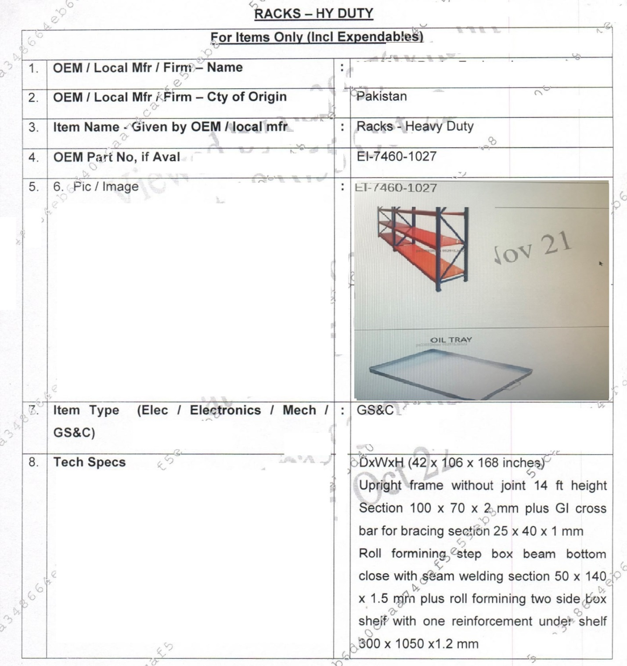
Tender Ser : 01

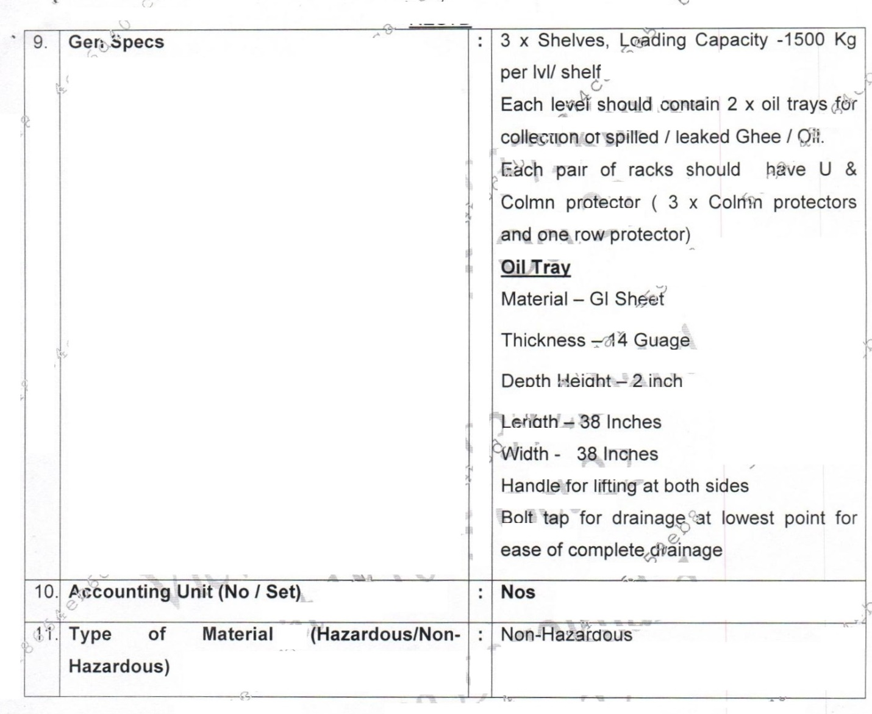

Tender Ser: 02
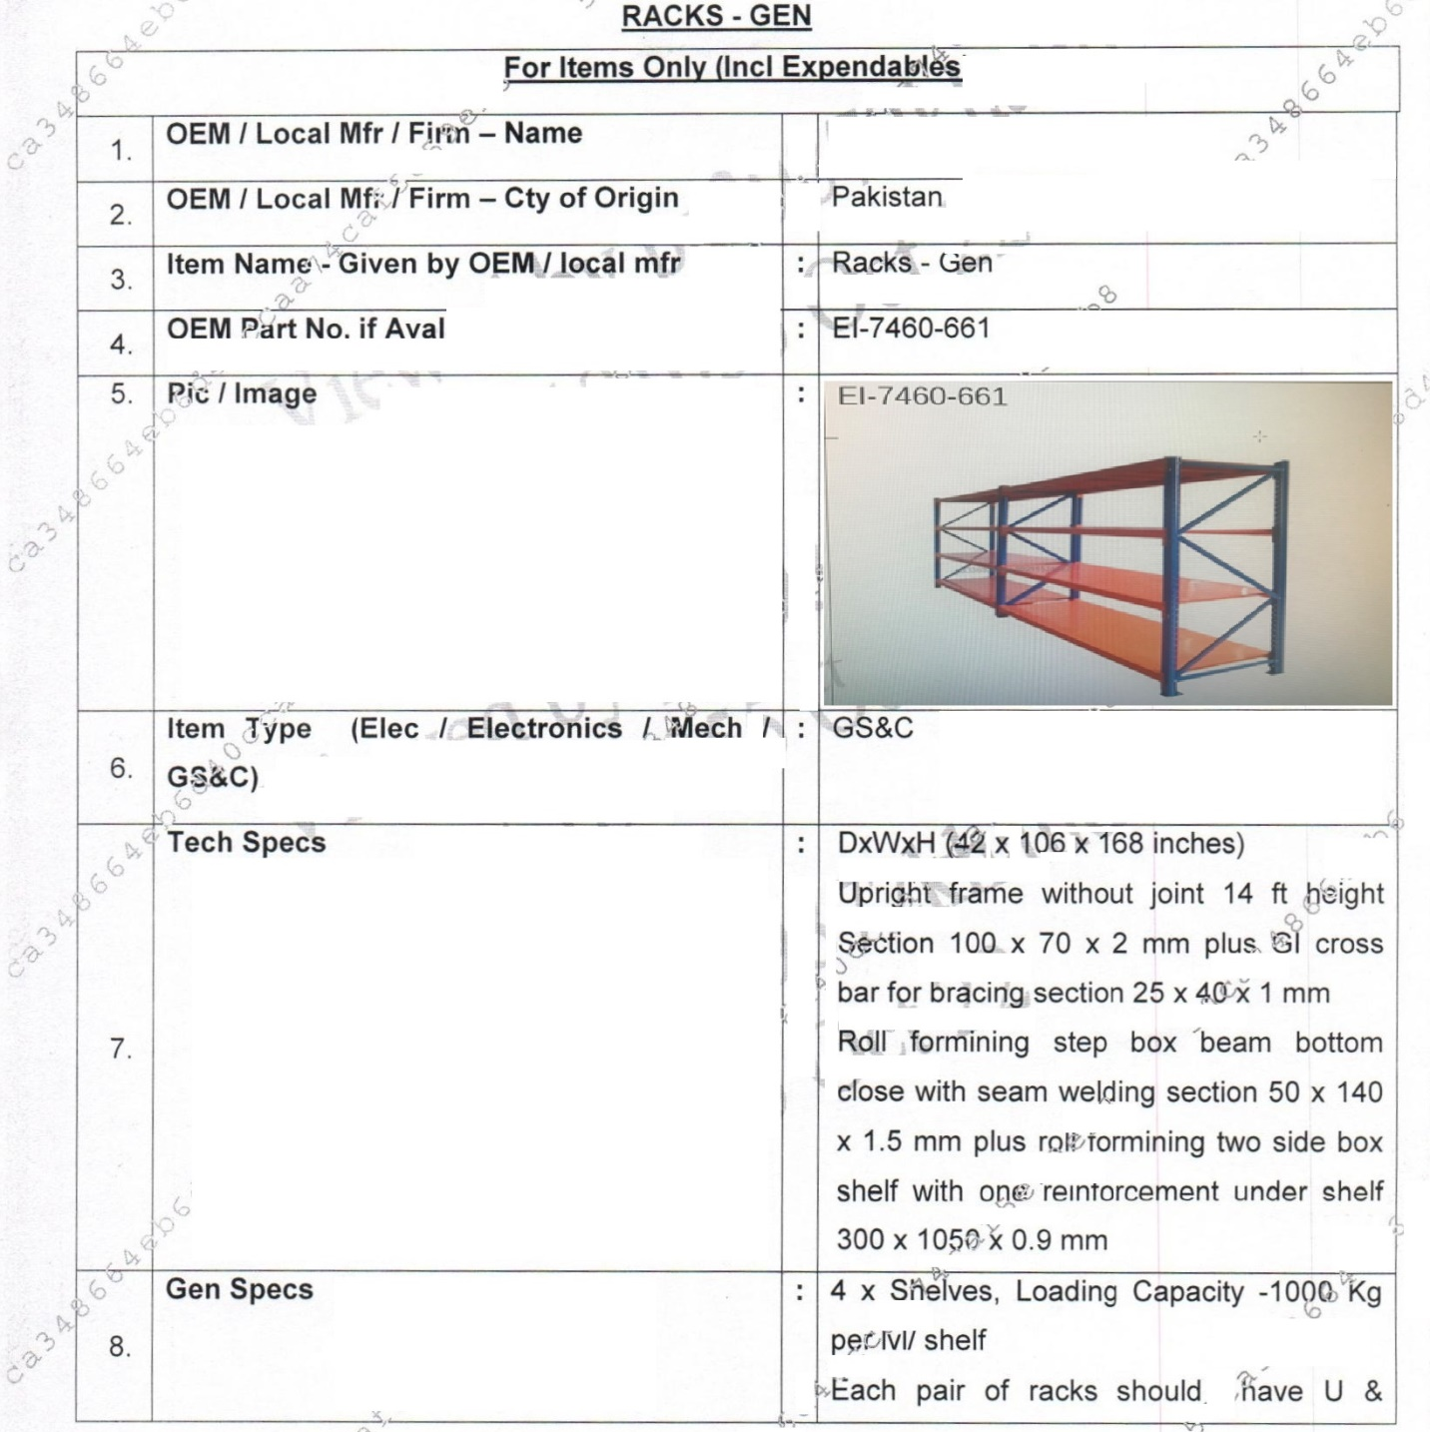
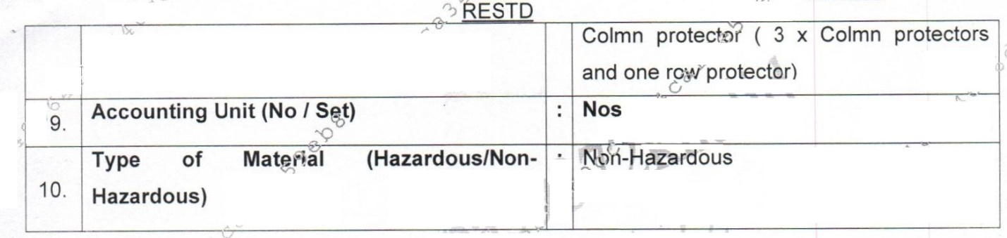
Tender Ser: 03
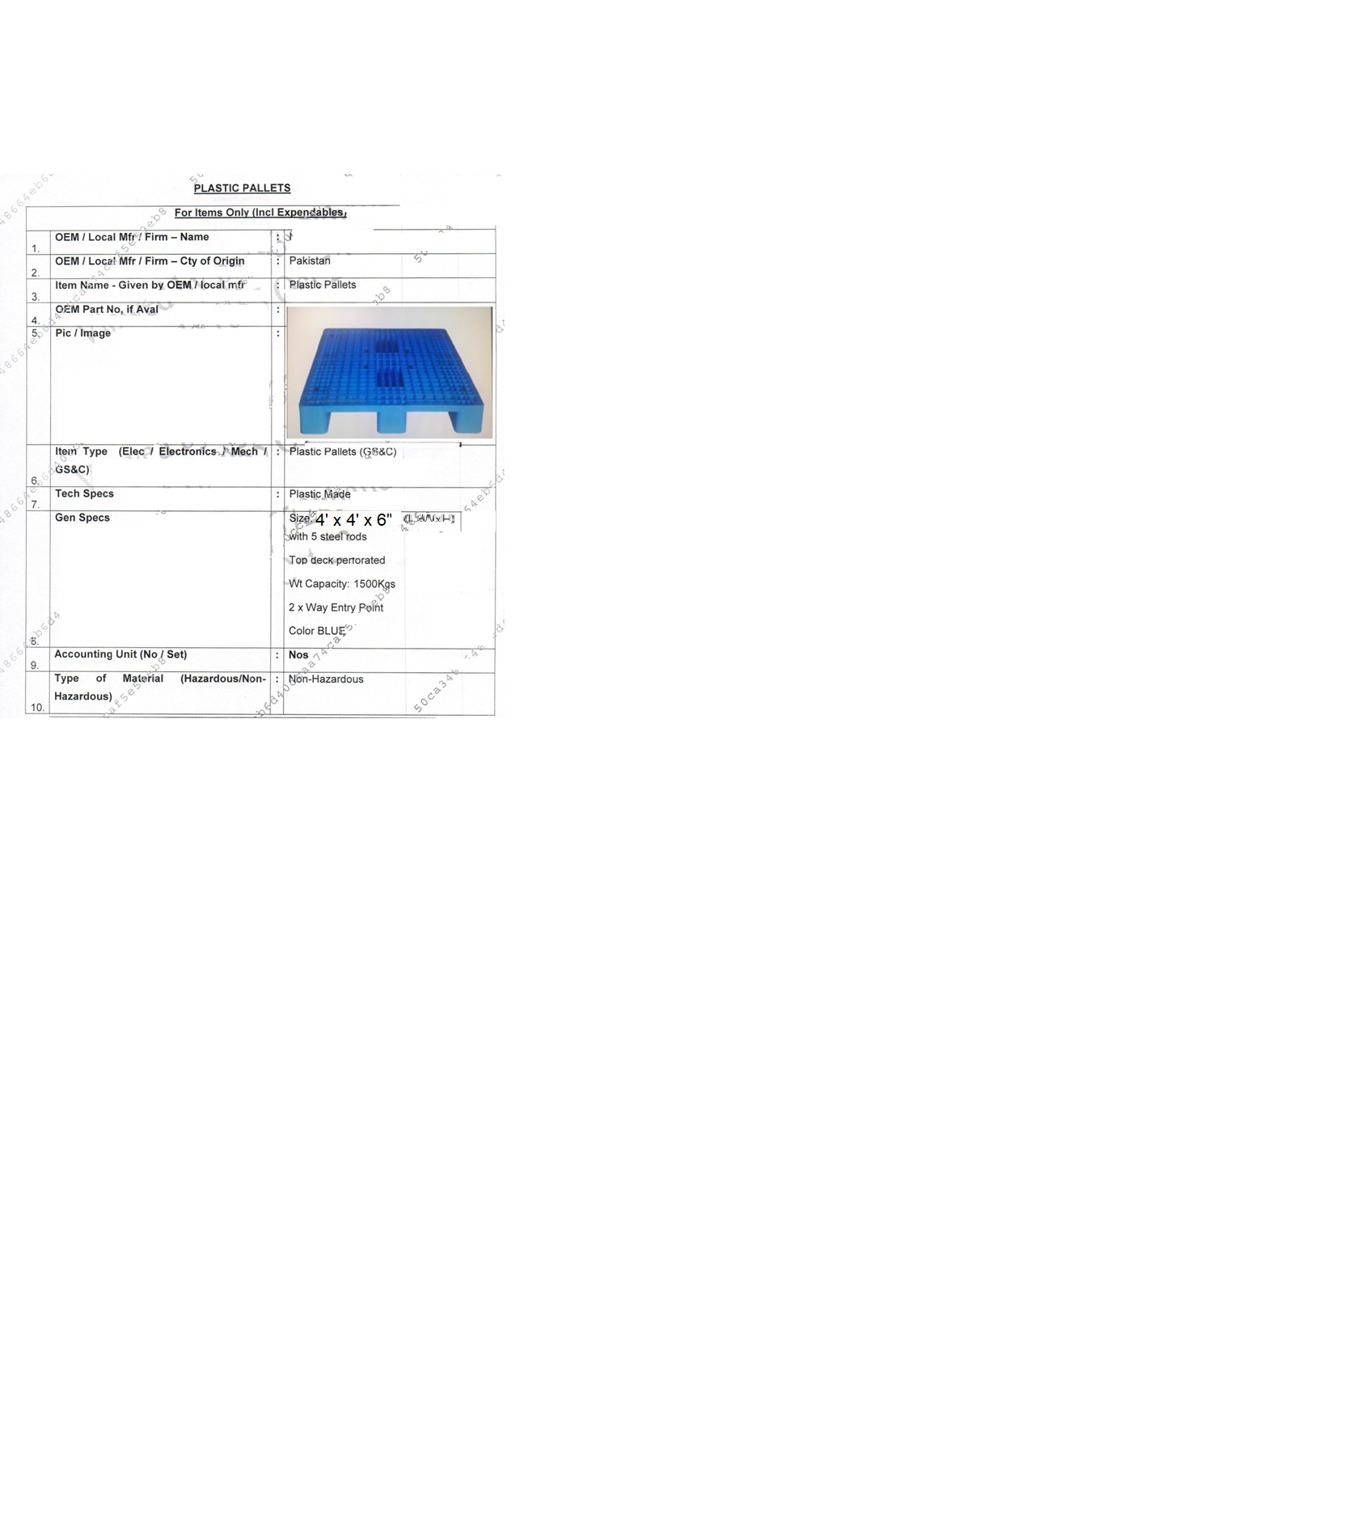

Tender Ser 4:
Pedestrian Pallet Stacker

- Item Name – Given by OEM / local mfr | - Pedestrian Pallet Stacker
- OEM Part no, if Aval | - EI-3930-1166
- Picture / Image | 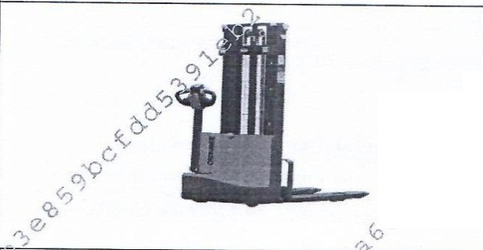
- Image of ident plate (clearly Legible) | - Not Aval
- Item Type ( Elec / Electronics / Mech / GS&C) | - Electrical
- Tech Specs | - Engine – AC Tech, Fully automatic
- Gen Specs | - Loading Capacity 700-800 KGs lift Hight 12,13 ft Should be able to op in 7 ft Aisle  - Fork Should be able to lift / rack 4 ft std pailet
- Accounting Unit ( No /Set) | - Nos
- Type of Material ( Hazardous/Non-Hazardous) | - Non-Hazardous

